Assignment WBS Monitor

Date : 12-Mar-2018

By : Peter Nocker ([p.nocker@roc-teraa.nl](mailto:p.nocker@roc-teraa.nl)), Benjamin Porobic ([b.porobic@roc-teraa.nl](mailto:b.porobic@roc-teraa.nl))

Hours : 24 hours (4 weeks, 6 hours a week)

Assessment : individual

Read the assignment carefully and ask questions if anything is not clear.

# Introduction

A WBS (Work Breakdown Structure) is a method to divide your project into smaller more manageable pieces that can be more easily estimated and controlled.

When you develop a product it is important to know how much time you will spend on a certain project because you don’t want to spend more time than you get paid for. The easiest way to make a project schedule is to use Microsoft Excel. But the big disadvantage of using Excel is that it is not a real time tracking software, when you finish a task you have to add the time manually in the spreadsheet. In the following weeks you will “translate” this spreadsheet in to a web application named: WBS Monitor. WBS Monitor is a time tracking web application, with the possibility to track time from multiple tasks and projects.

## Responsive

Smartphones and tablets are popular devices to browse the internet. That is why it is important to make your WBS Monitor responsive. This means that the layout of your website adapts to the viewing device of the visitor. You will be using Twitter Bootstrap to make your website mobile friendly.

## Techniques

To create this project, you will use the following programming languages and techniques: HTML, CSS, PHP, jQuery, AJAX, Twitter Bootstrap.

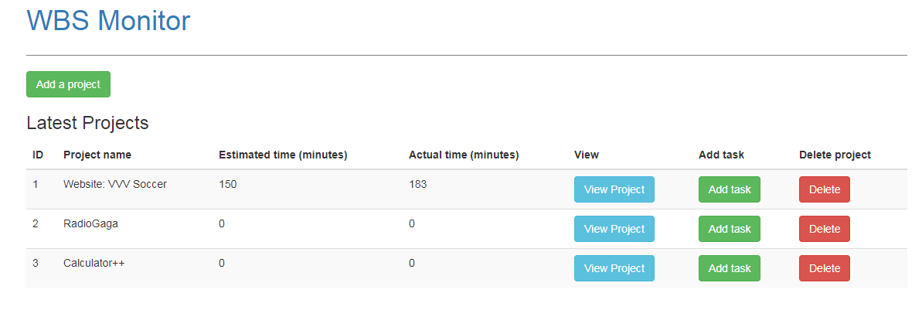

Figure 1 Projects overview page

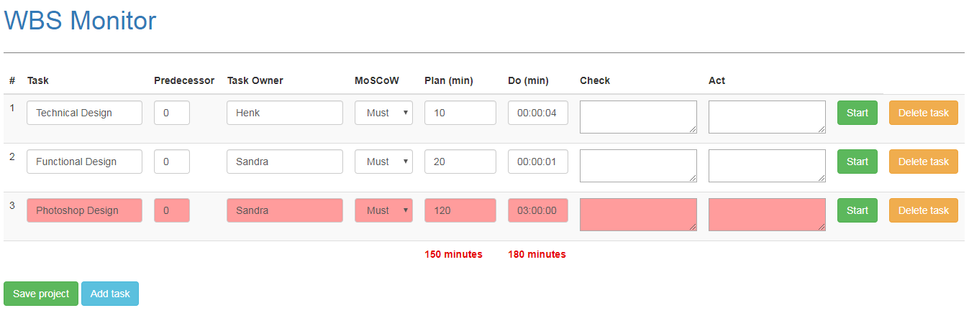

Figure 2 Project detail page

Prior knowledge

To successfully complete this assignment, it is necessary to have a good understanding of HTML, CSS, jQuery, AJAX and PHP.

# Must

* Possibility to add unlimited number of projects
* Possibility to add unlimited number of tasks per project
* Possibility to delete projects and tasks
  + When you delete an entire project all the tasks of that project should be removed from the database
  + When you delete a task the total time updates
* Project (see figure 1):
  + Name of the project
  + Show total time you estimated for a project
  + Show total time you actually worked on a project
* Task (see figure 2)
  + Every task consists of the following input fields:
    - Id
    - Task name
    - Predecessor,
    - Name of the developer
    - MoSCoW (Must, Should, Could, Won’t)
    - Plan (estimated time)
    - Do (Actual time)
    - Check
    - Act
  + Track time per task
  + Show total time you expect to work on all the tasks together (plan)
  + Show total time spent on all the task (do)
* User feedback (feedback messages):
  + Show a notification when users want to delete a task or project
  + Notification when users add a task and project
* Normalize your database, your database structure should be efficiently organized
* Entity Relations Diagram (ERD)
* Responsive / mobile friendly
* Test your website in different browsers and devices
  + Show a test plan that you have tested your WBS Monitor in different browsers and devices
* Clean code: no inline CSS, jQuery
* Organize files and folders

# Should

* Form validation (check for correct input and empty fields)
* Indicate with a colour that the time you actually spent on a specific task (do) is more than the time you have planned (plan) for that task.
* Indicate with a colour or icon that the total time you spent (do) on all the tasks together is more than the time you planned (plan).
* Predecessor check is working.

# Could

* Make a filter on the project detail page
* Make a login
* Use a PHP-framework (if familiar, during this project you won’t teach how to use a PHP-framework)

# Won’t

* Use a template

Tips & resources

* Use classroom examples and PowerPoint sheets from N@tschool.
* Make backups: external hard drive or cloud storage
* Upload your finished assignment in N@tschool. Use Winrar or 7-zip to pack your files
  + **Only .7zip or .rar file extension allowed (Do not upload zip files)**
  + Filename: ***firstname_lastname_wbs.rar***
  + Filename example: **john_doe_ *wbs*.rar**

**Reference**

* HTML & CSS
  + http://htmlreference.io/
  + <http://cssreference.io>
* PHP
  + [https://www.w3schools.com/php/](https://www.w3schools.com/php/php_looping_for.asp)
  + www.php.net
* jQuery
  + https://learn.jquery.com/

**Courses**

* www.udacity.com
* www.codecademy.com
* [www.freecodecamp.com](http://www.freecodecamp.com)

**Note**

* **Work together if necessary, but** **do not copy**. **In case of fraud, you have to create your own assignment with the same techniques as this one. You have to discuss this with your teacher!!**